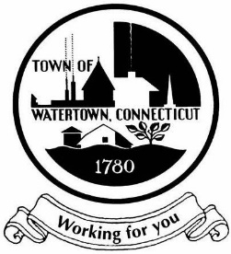
TOWN OF WATERTOWN
WATER AND SEWER BIPARTISAN COMMITTEE
MONDAY March 23, 2026, 5:30 PM
SPECIAL MEETING NOTICE

WATERTOWN TOWN HALL
TOWN COUNCIL CHAMBERS
61 ECHO LAKE RD WATERTOWN, CT 06795

- Call meeting to order.

- Roll Call

- Public Participation – the public is invited to speak on the proposed recommendations

- New Business:
Make any adjustments to the final report.
Set date for TC presentation.

- Adjournment

